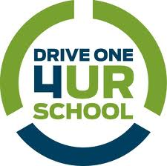
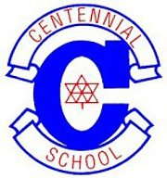

Centennial Secondary
After Grad 2012
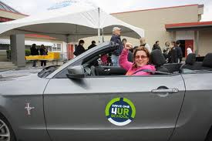
Centennial Secondary School After Grad 2012 is partnering with Metro Ford to host a Ford Canada Drive One event on Sunday June 3rd from 10 AM – 2 PM. The event is being held in the school parking lot off Winslow Avenue (right across the street from the Coquitlam Farmer’s Market and Dogwood Pavilion). Come by to take a new Ford Vehicle for a test drive and try the new “MyFord Touch” in-car voice activated technology and see how the new “Active Park Assist” works wonders to parallel park your vehicle for you (look Ma, no hands!). For every qualifying test drive (one per household, 18+ years old, valid drivers license), Ford Canada will donate $20 to Centennial After Grad. Come out for a Sunday drive and support our After Grad program. For further information, please contact Coleen at 604-939-7334.

